

**IFPN SECRETARY Report**

**July 2020- August 2021**

Another year has been completed as Secretary of IFPN, and it has been a challenging year especially with the COVID 19 Coronavirus continuing to impact on the healthcare industry and also the world dynamics.

**IFPN Meeting 2020** was delayed and held January 2021. 10 Board members, 4 apologies attended Virtually via Zoom teleconference. A successful productive 3 hour meeting, thank you for Patrick’s employer Deloittes who offer their zoom account for this virtual meeting.

**Executive Teleconferences.** The executive have had 6 constructive teleconferences in the current 2020-2021 board year.

* 13th November 2020
* 12th December 2020
* 7th February 2021
* 10th April 2021
* 1st July 2021
* 30th July 2021

**Whatsapp** has been actively used especially by our President and member’s.

**Website**. Ongoing updates with additions of Newsletters, President reports, Photo Gallery, Board Members Representative changes as new association President’s are elected. See appendix with website Data, we have about 80 visits daily (approx. 2500 per month) across a broad range of countries , so continuing that info is up to date, fresh information is vital. The project opportunity to review current IFPN Practice statements will be also value add to websites relevance

**IFPN 2021 Meeting**. Due to be held at AORN 2021 meeting, decision made that IFPN meeting would be virtual, in 2021. AORN face to face conference cancelled late July.

**IFPN Meeting 2022** is scheduled to be held in conjunction with PNC NZ Conference IFPN Details to be sent out by the next executive team re AGM date and time

**Communications to Board**. As secretary my main work has been for forwarding on International Council of Nurses (ICN), and other health communication news to Board Member’s via email.

**2021 Reports**

As at 31st July I have received five report’s for end of IFPN year have been received these are from GORNA (Greece), AfPP ,ORNAC, IPNA and PNC New Zealand all have been uploaded to Website. Reminder sent out to all Board Member’s 31st July 2021.

**Incoming Executive Elections**. Sue Lord undertook the role as independent judicator for this process. The successful new team is to commence 1st January 2022 are Patrick Voight (President), May Karam (Treasurer) and Meryem Yavuz van Giersbergen (Secretary). I wish them a successful three year term. In the following few months I will be liaising with Meryem to ensure a smooth succession handover of secretary role occurs.

**Recommendations**

* Look at gaining some more video clips of clinical practice techniques ie Gowning and Gloving, Aseptic technique, Diathermy safety as an additional education stream. These may come from industry sponsorship or IFPN member’s.
* Potential to have a Newsletter developed and sent out Quarterly to member’s, interested follower’s who ask to be on a mail list and placed on the website.

Yours sincerely

Sarah Bird

IFPN Secretary 2018-Dec 2021

MACN, MAAQHC, FACORN

Report emailed 1st August 2021

**2020 IFPN Website Statistics**

**Report from Mesuva web development**

I've attached a screenshot of the statistics for **ifpn.world**

It's the **Visits** numbers that are relevant here as a measure of activity.

As this kind of traffic summary uses very raw data, the numbers need to be treated as very rough, and more about trends rather than anything exact.

I'd suggested rounding down the visits by about a third, to account for robots and others that aren't necessarily real visitors.

These types of numbers may continue to be sufficient for your reporting, but if you are wanting something more specific we'd need to add Google Analytics to the site.

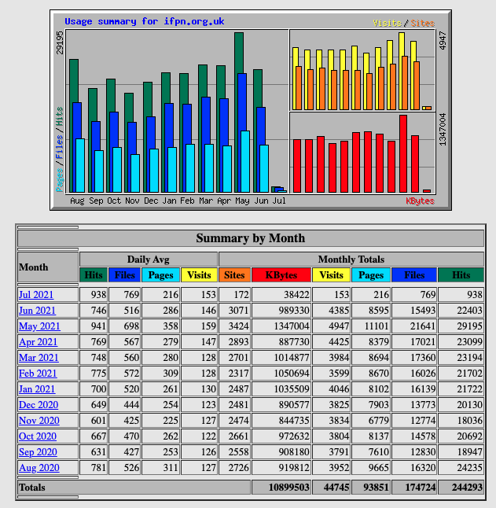

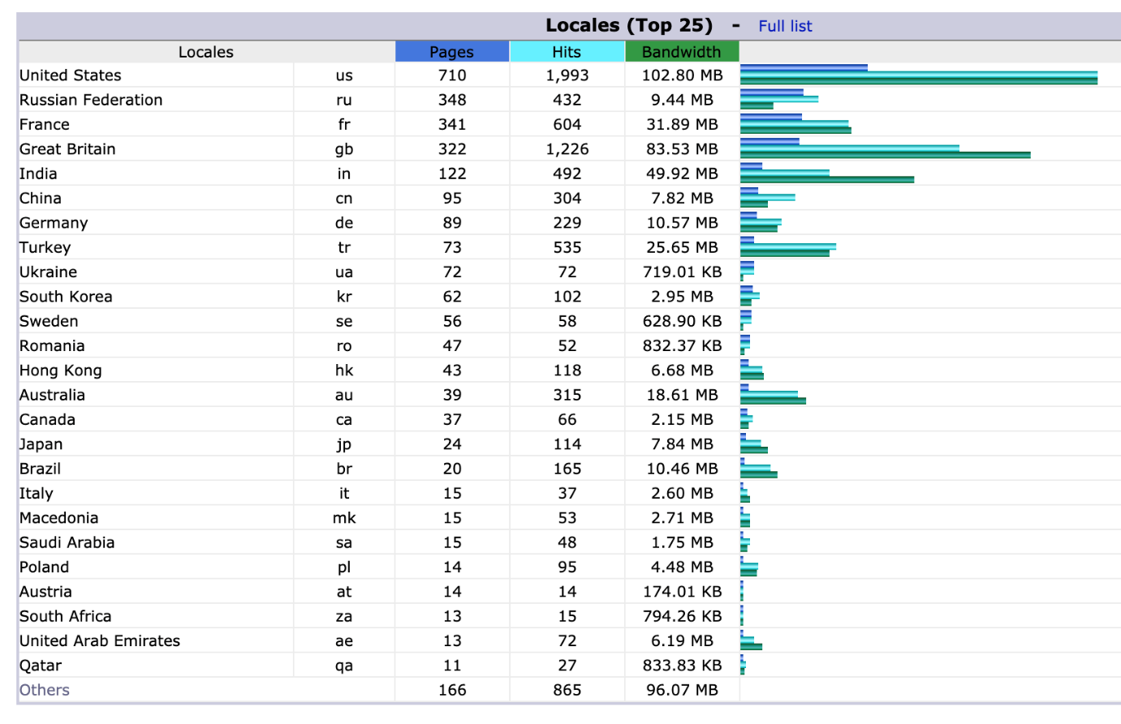

Kind Regards

-Ryan

**Ryan Hewitt**

**Mesuva Web Development**email: [ryan@mesuva.com.au](mailto:ryan@mesuva.com.au)  
phone: (08) 8121 4440  
website: [www.mesuva.com.au](https://apac01.safelinks.protection.outlook.com/?url=http%3A%2F%2Fwww.mesuva.com.au%2F&data=04%7C01%7C%7Ca27801c75fd64ba74ae308d8b7b76573%7C84df9e7fe9f640afb435aaaaaaaaaaaa%7C1%7C0%7C637461346241467771%7CUnknown%7CTWFpbGZsb3d8eyJWIjoiMC4wLjAwMDAiLCJQIjoiV2luMzIiLCJBTiI6Ik1haWwiLCJXVCI6Mn0%3D%7C1000&sdata=URVGkWtARqosCqduEQ68eLAvXyJ5gpFHS%2F9HtpQPvxA%3D&reserved=0)