Perioperative Nurses College of New Zealand (PNC) (New Zealand Nurses Organisation (NZNO))

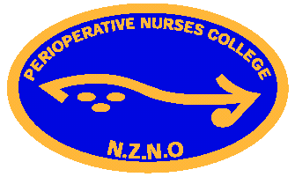

The PNC represents perioperative nurses in New Zealand. Our focus is professional development and representing Perioperative Nurses interests throughout the healthcare sector. We continue to make representations and submission to our Ministry of Health and other national organisations on diverse topics such as Melanoma Standards of treatment and Crate weights.

The last year has been challenging. Even though New Zealand has, so far, escaped the disastrous effects of COVID-19 that so many of you have experienced-it has still impacted us significantly. As a small, isolated nation with our borders effectively closed we are feeling the impact of staff shortages. We traditionally rely heavily on internationally qualified nurses (IQN’s) to fill the gaps in our healthcare system. The IQN’s that are already here have been unable to see their families or bring them into New Zealand. As a result, some have returned to their home countries; others are experiencing the trauma of being parted from their loved ones during a time of crisis. Our workforce is depleted and the pressure on those remaining is beginning to tell.

As a College, the PNC is experiencing a tough environment for promoting Professional Development. Due to staffing shortages, hospitals are reluctant to release staff for Study Days. We are working together to find new and innovative ways to promote Perioperative nursing development. We have our National Conference in October this year-this was postponed due to COVID-19 restrictions last year. Although online forums are a bonus in times of restrictions, we are all looking forward to the opportunity to meet with our national colleagues in person.

Juliet Asbery (Nurse Practitioner)
Chair of the Perioperative Nurses College of New Zealand (NZNO)

