Current IFPN Board Members.
Welcome to IFPN. Our organisation is young and dynamic and works hard to fulfil the objectives, the strategic aims, and the current work in progress.
We have 14 country members:-
- AfPP(United Kingdom)  - ACORN (Australia)  - AORN (United States of America)  - EORNA (Europe) (25 countries)  - GORNA (Greece)  - IAoRPN(India)  - JONA (Japan) | - KAORN (South Korea)  - ORNAC (Canada)  - PNCNZ (New Zealand)  - PNGORN (Paua New Guinea)  - SOBECC(Brazil)  - TSORA(Turkey)  - FEGREM (Mexico)
We also have 2 Pre-members;_
- CORN(China)
- PIORNA(Pacific islands).
IFPN represents approximately 450,000 perioperative nurses around the world, and we are actively introducing potential new members to the benefits of membership.
Note as at July 2019, two further countries are in active discussions with IFPN Executive to join IFPN.

About IFPN
We are a global organization dedicated to actively promoting perioperative nursing. The International Federation of Perioperative Nurses supports perioperative nurses working towards globally improving patient care by promoting safe surgery and evidence- based best practice standards, through research and education in collaboration with member organizations and other relevant collaborators.
Our Vision is:
To actively promote perioperative nursing globally
Our Mission is:
The International Federation of Perioperative Nurses will support perioperative nurses internationally to improve patient care by promoting evidence-based, best practice.

IFPN Membership

Benefits of Membership
Membership in the International Federation of Perioperative Nurses (IFPN) provides an opportunity for members to network and interact with their colleagues globally, to gain knowledge and participate directly with the International Council of Nurses [ICN], and to enhance and share their knowledge with perioperative nurses throughout the world to assist in providing the safest, most efficient to perioperative patients.
As the only perioperative nursing affiliate of ICN, members have a valuable link to this prestigious organization and share in the information from ICN via website links with relevant surgical ICN posts also added to IFPN website.
As education is the key to enhancing perioperative patient care, the IFPN has collaborated with members to provide an educational session in conjunction with the annual IFPN board meeting. The IFPN networking sessions have served to demonstrate that we all have similar problems with unique solutions to improve practice and serve to enhance patient surgical care. The IFPN website also has a list of website links of some links to assist in the learning of perioperative nurses worldwide and further suggestions of links or tools that are available are readily accepted to add to current
Several past IFPN Board members are Ambassadors to assist developing countries/regions to grow perioperative nursing education with support, with an aim to foster commencement of a association that may eventually join IFPN, a great example is Papua New Guinea. Other regions with support commencing include Africa and hopefully soon South America.
This is but a snapshot of the value of becoming a member of the International Federation of Perioperative Nursing. We hope you will take the opportunity to explore the website, evaluate the value, and fill out the membership application form. We would welcome your input.

Membership Types
Full Membership
Is available to the largest national perioperative nurses' association within a country, or an equivalent perioperative nurses' group affiliated to the official nursing organization.
Requirements: the association is a section of a health workers' organization; the section has its own separate regulations which are not in conflict with Article 2 of the IFPN constitution or with the purpose and objectives of IFPN; the association or unit is controlled by perioperative nurses gaining its authority from its members, and speaks on perioperative nursing matters; the association or unit is represented by nurses in all IFPN activities.

Pre-Member Status
Is available to an individual country without a recognised Perioperative Nursing / Operating Room Nurses Organization but which is working towards forming such an organization.

Other Important Information
The Annual Subscription is £255 per country association. ( as at 2018)
The IFPN Board is comprised of the Executive and President of each of the Member Associations. Meetings are held once per year in collaboration with a preselected member association conference. An informal gathering may be planned whenever a number of Board members are present, i.e. the International summit held preceding the AORN Congress.
Previous past four years formal meetings have been held in:
- 2015, European Operating Room Nurses Association EORNA, Rome, Italy
- 2016, Australian College of periOperative Nurses (ACORN), Hobart, Australia
- 2017, European Operating Room Nurses Association (EORNA) and Greek Operating Room Nurses Association (GORNA), Rhodes Island, Greece
- 2018, Association periOperative Registered Nurses (AORN), New Orleans, USA
- 2019 is scheduled for AfPP York, University York, Yorkshire, United Kingdom,
The advantages of a global network in which to share practice include the resources of many to seek solutions together. Almost every issue is one that has been resolved at some time somewhere, by someone, and by sharing solutions we can save time, learn beneficial lessons from colleagues and share experiences.
The website is the portal to discover the organisation, to share our vision, goals and aspirations and to further the aims of IFPN.
We hope that you and your association will be interested in joining IFPN and to further promote quality Perioperative patient care around the world. If you have any further questions or would like to contact us, please email info@ifpn.world

WEBSITE
www.ifpn.world
This has information on:-
- Upcoming conferences,
- Current board members,
- Perioperative nursing and surgical recent news.
- Useful links resources for perioperative nurses
- Photo gallery and board members area.
Any information for up loading please send to secretary@ifpn.world
Board area has information for the board members this includes
- Papers from past annual general meeting’s and paperwork for future meeting
- Constitution Templates of forms and power point presentation
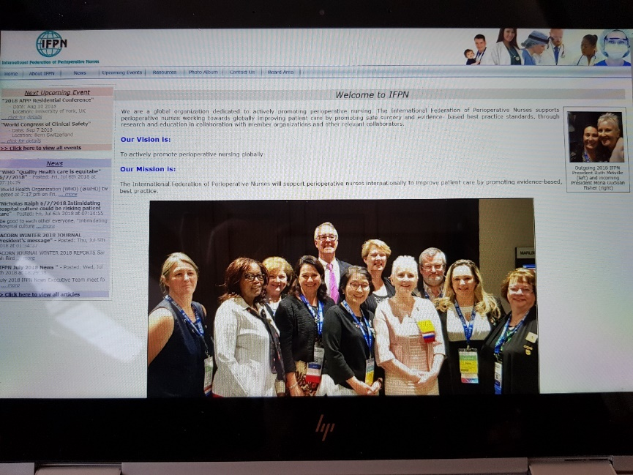
(Photo of IFPN Board at 2018 Meeting in New Orleans)

Communication
- Whats app chat room ( IFPN)
- Twitter : @IFPNPresident
User Name and password will be sent by IFPN secretary once member has a financial member
Required from each new board members
- Recent Photo of current President for website
- Current email address and contact phone number
- Ongoing conference information
- Updates for member country re number of members
- Conference update
- Editorial’s from membership publication for sharing

Annual General Meetings
Held annually meeting site known 18 months ahead.
Applications are called for by the 30th June annually for meeting two years ahead. The Board Executive assesses and sends out applications to all financial board members by end of July annually with vote completed by mid August and decision announced by executive team by end of August if all goes to plan.

Executive
The President, Treasurer and Secretary of IFPN are previous members of the board who are voted in by board members.
They hold a three year tenure. There is a set of guidelines for the executive voting which are available on the IFPN Website for member viewing.

HOW TO APPLY

There is an online application portal on the ifpn website at the bottom of the page
https://www.ifpn.world/about-ifpn/membership/membership-application
Please contact secretary@ifpn.world with any enquiries.

